Wilfrid Laurier University

Project Technical Report

Lorand Kis

Shaza Najeeb

UX230: Interaction Design

December, 13th, 2021

Project Introduction:

For our deliverable 2 assignment, we have chosen to provide a new iteration of Laurier’s Safe Hawk app, and consists of developing a pleasing and effective platform for staff and students to control all matters relating to mental and physical health at Laurier. Our goal is to improve the already existing Laurier SafeHAWK app and create an effective, easy to use/understand application that will minimize errors and maximize usage.

Users have found it difficult to navigate throughout the app. This is due to the fact that it is not seamless and there are several unnecessary steps and pages that users are required to go through in order for the user to complete a simple task such as switch from the Waterloo to Brantford section of the application. The application also needs to be visually appealing as well, attracting more users. The lack of color, and white space draw attention away from the application and rather emphasize the emptiness, and bland design. Furthermore, the application looks as if it is almost unfinished, and under construction.

Three tasks to integrate into the Safe Hawk app that will improve the product are:

* Customization: When users login, all of the information on the application should pertain specifically to them. For example medical documents should only be displayed if a user has filled it out already, or needs to do so.
* Keeping users Informed: Users should know what the university requires of them as well as what is happening on campus. Which is why there is a news system on the application, updating users with information they need to know.
* Keeping users out of their own way: Partially tying in with customization, we want to keep users out of their own way by limiting their human error (this is done by edging on the side of constraining the user’s activity to only what is absolutely necessary). As this application is used primarily for the health of users, it can be extremely unsettling and dangerous for human errors to occur here. An example of this through the use of constraints is, for example: users cannot edit the information on their own profile. This is due to the fact that the information on their profile is based on previously completed documentations that the university holds and updates (this is the safest option).

Also taking into consideration our user of this application (staff and students), we have to insure that, the mobile application is free (due to price sensitivity), and that Laurier shows confidence in the applications ability (so that a feeling of valid security is provided to users)

Staff and students will need to initially log in so the platform's content will be tailored specifically to them (and house all relevant information about them), as well as having health data made available for authorized staff/admin to view (provides a much easier option to staff when they need medical records).

The research methods we’ve used are:

* Quantitative secondary observational research (gathered from the government of Canada and other sources) to compose consumer profiles for both students and staff, which is further used to make vital decisions in the development of the Safe Hawk app.
* A survey that was conducted to set information from our domestic population regarding their thoughts and feelings towards the current version of the application.

Consumer Profile 1: Students

75% of University students between 17 and 27 years of age and 90% of students are under 40 years old. Wilfrid Laurier houses people of all genders however the University's population sways slightly female (56.8% of Canada's University population is female and Wilfrid enrolment statistics follow a similar pattern). With the location of the University being in Ontario approximately 90% of the University's population resides in Canada with the rest being International students. Not much data is available specific to Wilfrid Laurier but we can assume that approximately 69% of students are a part of a dual parent family ( derived from the general Canadian population) approximately half of students are reported single with 1/3 in a non-marital relationship and the remaining population in another form of reporting relationship. Approximately half of the University population in Canada is working with a ranging salary of $16.49 per hour to $33.58 per hour depending on experience and level of degree in pursuit of the student. There are no other medical applications for students particularly pertaining to Wilfrid Laurier University. Some decision factors to take into consideration are:

- Safety (feeling of being secure using product)

- Cost

- Balance (appropriate for product's nature) between functionality and ease-of-use.

Students are extremely price sensitive. They tend to always look for a cheap or free option especially when it comes to mobile apps. This is due to the restricted salary of many students currently attending higher education (inferred from student income). Some other motivating factors we should keep in mind are the wants, goals, and desires of students:

(Not statistically supported, inferred from personal and environmental experience)

- Students want to obtain a good career in their industry of choice.

- Students wants to obtain good results in their studies ( this is a sub goal of wanting a good career)

- Students with financial stability (one parent motivation for a good career).

- Students wants to develop academically and be challenged (a second-parent motivation of both career and study)

- Students want and work towards being economically and socially independent (especially in relation to parents/guardians)

Furthermore some regular behaviors/tendencies of our student population are:

- Studying

- Socializing

- Reporting administrative requirements when needed

- Taking care of personal health needs (eating, sleeping, exercising, etc...)

- Indulging in entertainment and relaxation

Consumer Profile 2: Faculty Staff

The median age of university staff working full time ranges from 38 to 58 years of age, With the general work population getting younger in recent years. The gender statistics of full time teaching staff in Ontario is made up of 59.1% male staff and 40.9% female staff with less than 1% of staff being a non-binary gender. With the exception of staff working in the Chongquin office in China. Virtually all of Wilfrid Laurier staff live in Canada (more notably in Ontario). The majority of full time staff at Laurier are either in a marital relationship, have children, or both (This is due to the nature of the population's age). The average salary for full time teaching staff at Wilfrid Laurier University is $150,025 for all ranks combined (including deens). Aside from demographics some diction factors to take into account when designing the application is:

- Safety (feeling of being secure using product)

- Ease of use.

As all staff are paid, they are not as sensitive to price as students would be (Inferred from staff income). Another factor to take into consideration for pricing would be that the application pertains to work health, and that it may be perceived as a product of minor importance being an app. Also an important factor the SAFE HAWK app needs to keep in mind, are the wants, goals, and desires of our staff:

- Staff want to amass an income to provide for their families.

- Staff want to support student’s learning.

- Academically based staff want to expand and challenge their knowledge.

Furthermore the behaviors/tendencies of staff during their everyday life:

- Teaching/attending to work responsibilities.

- Attending to, marital and parental responsibilities.

- Reporting administrative requirements when needed.

- Taking care of personal health needs.

- Indulging in entertainment and relaxation.

Some of the ways that our product aligns with both our staff and students is with:

- The mobile application being free

- Not only supported but provided by Laurier (feeling of valid security is provided to users)

- Having staff and students initially login allows the platform's content to be tailored specifically to them (as well as housing all relevant information about them).

- Having health data made available for authorized staff to view.

We decided to retrieve more data from a wider demographic of Laurier students this time. We did this to help us ensure we were getting a general consensus, with more opinions, feedback and statistics. We sent out a google form titled “What do you think about the Laurier SafeHawk App?” This google form was sent out to several Laurier leaders apart from different commits, programs, clubs etc... Which was then sent off to Laurier students. The google form had several questions that ranged from having the user tell us about themselves such as year, name etc.. Then the second part of google asked about their use of the Laurier SafeHawk app. Such as why do they use it? How do they use it? What do they use it for? And how often do they use it. We also asked for some raw and real feedback. We asked our users to talk to us a little bit about the application, and what they think can be improved about it. What we wanted to understand was what issues or areas of improvement they suggested. This feedback was incredibly helpful and valuable to us because it allowed us to understand issues, errors and mistakes the application had from a variety of users who regularly use the application. Collecting insight was helpful as it helped us create a more established and clear vision about our process.

Collecting data virtually through a remote setting was easy and efficient for the most part. It was to the point and direct, which helped us get several responses from the Laurier community. The only challenge that was faced was the response we received that had a lack of detail in the answer. The lack of detail and short 2-3 word responses where some users wrote responses such as “good '' or ``not good” were not very effective as it did not allow us to further analyze and understand what they were saying, and resulted in some responses not contributing to our data collection.

To give you an idea of what kind of insight we received I put together a chart that divides and summarizes users' responses from the data that was collected

|  |  |
| --- | --- |
| Type of issue | Specific Concerns/comments |
| Visuals | * Make it more visually appealing * Larger text * More color * More visuals * The app's visual design and aesthetics could be improved a lot. App feels like a cheap sketchy website. Design has improved though since first released. Maybe get some art/design students to try to help or get a professional designer if possible. If you contact the art/design students or ask the art club for volunteers to submit designs or work with the app makers you could probably create something even better! |
| User Interface | * Improve the functionality * It is undeveloped * Several Technical issues * Make user interface less complicates * It is way too overwhelming * Make it simpler to get to the vaccine passport status and current covid status badge from the daily quiz. Maybe have a button to have them both shown on the app at the same time? The ymca staff require you to show them both badges to enter. Sometimes it can be long to get to both badges to load and show them. Another small thing involved with this, if possible make the covid badge and vaccine status badge loadable without wifi. This has been an issue a couple times. |
| Expand the application functions | * Lack of resources on the application * List of resources and support that are off campus * The safehawk app should just be the Laurier app. They should put school/event calendars, and different school resources on it. This way it's much easier than going to the school website. |
| Efficiency | * Constant updates to improve the speed of the app * Lack of organization * Make it easier and faster to complete covid 19 assessments * The app loads slow, maybe improve it by making processing times faster if possible. Also it glitches/freezes and crashes a lot when I hit the back button. My phone says "app is not responding" then the options are to close or wait * I don't like that every time you try to go back to the home page it asks you "are you sure" since most of the time it isn't a mistake and it's not like going back quits a form. Also feel like the app could look a bit more modern, but it gets the job done * Have a search Bar |

SAFE HAWK Design:

*Please follow this link to see the new Safe Hawk app designs:*

[**https://www.figma.com/proto/O207LerfXZ0knoo6fkes3A/SAFE-HAWKS?node-id=3%3A9&scaling=scale-down&page-id=0%3A1**](https://www.figma.com/proto/O207LerfXZ0knoo6fkes3A/SAFE-HAWKS?node-id=3%3A9&scaling=scale-down&page-id=0%3A1)

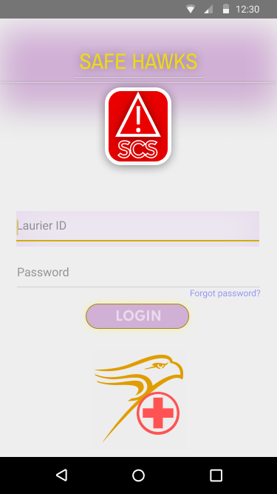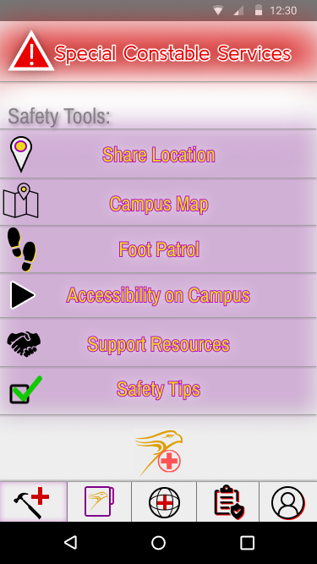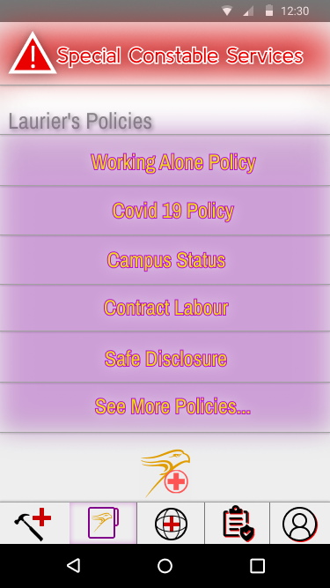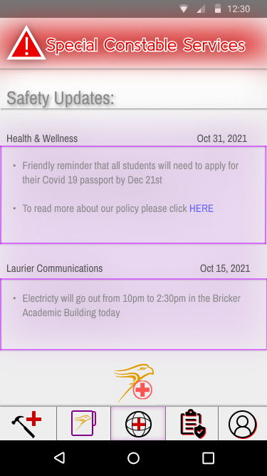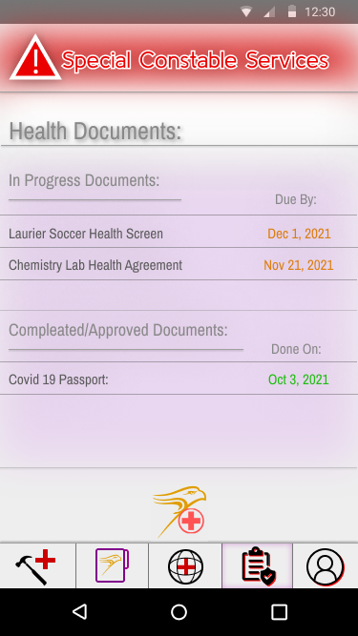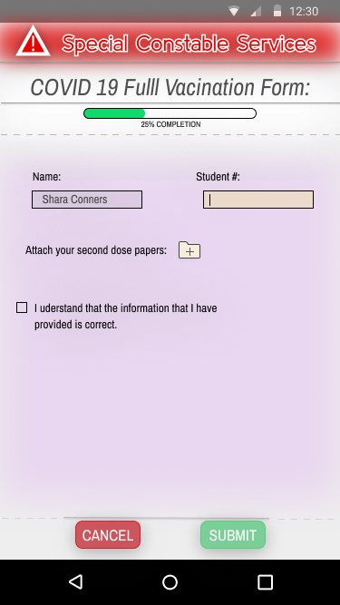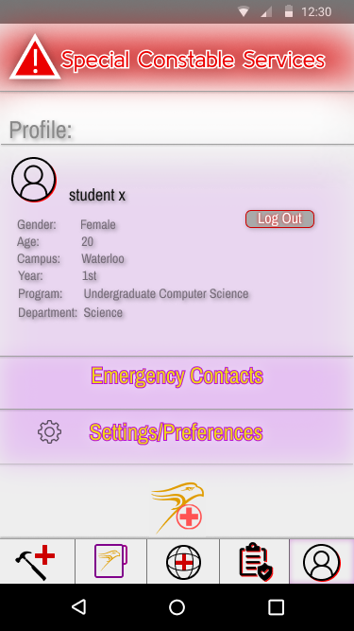

When developing the design of our application, we would want to first look at some design flaws that were made by the previous iteration of this app. Users of our survey said that when navigating the application, it was quite tedious when feedback messages would constantly pop up asking the users “Would you like to exit?”. Although the designers were trying to minimize user error in this situation, it became a source of frustration for users. Another issue of the previous Safe Hawk app was how the application asked its users to login/provide authentication. Users were asked to provide authentication when they wanted to utilize one of the application's functions, for example filling out the COVID-19 full vaccination form. This comes with many issues including confusion regarding the number of times that need to be signed in it (for example, if the user exits), confusion regarding where to sign out, as well as it removes focus from the task that the user intended to complete (in this case filling out the COVID-19 full vaccination form). Finally, the previous application of Safe Hawk was extremely confusing in its organization. It provided too many choices for users to make, categorizing between different campuses and displaying menus with far too many options, which led to further menus with yet more options. Through the development of this new Safe Hawk app, we want to provide seamless communication between ourselves and the users on how they can complete their tasks efficiently, while at the same time reducing errors in the actions of users.

The first design to talk about is the app’s login page. This page is displayed to the user right as they open the application. It provides one location in which users will authenticate their identity to the app, using their Laurier username and password. At the top of the page we see the title “Safe Hawks” To help the user identify the platform. Afterwards, there are two progressively larger horizontal lines signifying the start of the functional (Functions such as buttons and user inputs) proportion of the page. Also at the title there is a purple haze loosely resembling a rectangular block behind the gold text “Safe Hawks”. Just under the lines, we see a pronounced red and white button with a hazard symbol and “SCS” written on it, it is boldly defined and easy to see. We decided to provide the function to contact special Constable Services on the first page due to the severity of needing to call the special constable services and the time constraints that are most likely to be present in a situation in which they need to be called. Below the special constable services button, there are two text input boxes, the first prompting users for their “Laurier ID” And the one below for their “Password”, And with this in small blue text under the password input box, there is a button labeled “Forget Password?”, which users can press to receive assistance in the case they forget their Laurier password. Under this in a purple, gold lined button, “LOGIN” is written in white prompting the user to press it in order to log into their account on Safe Hawk. This button was added under the user input boxes to directly imply the order in which activities must be completed (users cannot click log in until they enter their ID and password). Finally, at the bottom of the page is the new Safe Hawk app logo, which is a combination between the Laurier logo and a medical symbol. Clearly defining the intent of the application and its relation to Laurier. This page’s use of affordances are as follows:

* Touch the screen: users can perform tasks allowed by the page by touching the screen.
* Call SCS: calling the special Constable services is often a serious matter and needs to be done quickly, so allowing users to call SCS on the first page of the app that is available to them (login page) is vital.
* Log into their account: the main function of this page is for users to log into the Safe Hawk app via their Laurier credentials.

As users know that they need to touch the screen to perform tasks, they need to know where to touch to perform tasks. To call SCS, there is a red and white button labeled with a hazard sign and “SCS” so that users can press it to call. For the process of logging in there, our first two text boxes that prompt users for their ID and password. When clicked, they will be able to type in with their phones keyboard system. Under the lower password input box, there is a well-recognized “Forgot Password?” button that many other apps and websites used to assist users in the case they forget their password credential. Finally, the login button prompts the user to click it in order to complete the login process, taking them to the app's main page. The biggest use of mapping on the login screen is from how the login button is placed under the password input box, which is placed under the Laurier ID input box. This communicates the order in which the tasks are to be completed to log in. Besides this, the only other instance of mapping is from the decision to place the SCS call button high, signifying its importance and keeping it out of the way of other functions to limit human error from the users. The conceptual model that the login menu employs is that of requiring identification, Similar to the situation of an LCBO employee requiring identification to prove users are of the legal age to purchase alcohol, the Safe Hawk app requests users to provide proof that they are authorized to view sensitive safe hawk information. Besides this, there are also the conceptual models that are intrinsic to the button and input textbox signifiers. Furthermore, the way that the login page has employed the use of feedforward, feedback and constraints is as follows:

* When a user clicks the SCS button to call SCS, they will be met with a window asking them if they would like to call SCS, giving them the option of yes or no. If they choose no, they will return to the login screen. If the users choose yes, however, they will be met with another page structured similarly to a regular smart phone call window. Will write out “Calling SCS…”
* The login button is also an example of feed forward as it lets the user know what will happen as a result of pushing it and when it is pushed. The feedback of being taken to the main page of the app is confirmation that the process worked. But the logon process can also feedback a constraint, when the user does not input all or the correct information and presses the login button, the user will receive “Your ID or password is incorrect!”.
* Finally, the login page makes use of semantic constraints. We see this on the “SCS” button that also has the graphical depiction of a hazard sign, communicating to the user that this button is to be used in an emergency situation.

Once the user is logged in, they now advance to the actual safe Hawk application. Within the application the next topic of discussion will be regarding some of the constant design elements throughout the main menus. Throughout all of the main menus, there are three consistent design elements that are present. Firstly, is the special constable services button at the top of the screen. Once again this is provided because of the nature of needing to call the special Constable services. In emergency situations, human error is much more likely to occur as a result of people’s panicked state, and instead of trying to navigate quickly through the application to find where the function, it is a much better alternative to simply provide the function to each page so that the user can clearly know where and how to execute the task of calling the special constable services. It is always placed at the top of the page, remaining out of the way of other functions on the page, and it uses the semantic constraint of having the hazard sign on the button, as well as helping reduce human error by providing the feed forward function of the application, asking the user if they would indeed like to call the special constable services. The next design element that we see throughout the Laurier Safe Hawk app is that of the horizontal bar at the bottom of the screen that allows users to switch between the different main pages of the application. There are five main pages of the Safe Hawk app: the “Safe Tools” page, the “Laurier’s Policy” page, the “Safety Updates” page, the “Health Documents” page, as well as the “Profile” page. The horizontal bar at the bottom shows the five icons mapped accordingly to each page. Users can click on any one of the five icons to display the desired page. The icons are: hammer with a medical plus sign to signify the safety tools page, a folder with the Laurier logo on it to display the Laurier’s policy page, a sphere symbol with the medical plus sign in the middle to signify the safety updates page (This sphere/globe symbol is commonly associated with news and reporting in general), a clipboard with writing on it to display the health documents page, and finally, a simplistic illustration of a person to display the profile page. The icons on the horizontal menu bar are mapped accordingly (from left to right) to provide the menus to users that apply more for general daily use and pertaining to information regarding the university to menus that pertain more to personal information and documents (this is once again maped form left to right). The Menu bar uses the conceptual model that is similar to the idea of a horizontal rolodex in which users can click across a horizontal bar at the bottom of the page to switch to different pages. Finally, the other element that is consistently within all of the menus in the safe Park app is the graphical design of the new Safe Hawk logo, which is a combination between the Laurier logo and a medical symbol. This is on all of the menus, simply to provide the connection between the application and all of its pages.

Moving on now, the discussion will contain the descriptions of all of the different pages on the Laurier safe Hawk app. The description of the specific pages will not include the elements that are continuous on all the pages that were previously discussed.

Firstly, the safety tools page: on the top of the page there is a label called safety tools defining the pages primary functionality. Afterwards, we can see an assortment of different safety tools Oriented as horizontal buttons being provided one after the other in a vertical fashion (These functions include: Share location, support resources accessibility on campus, Foot Patrol, campus map and safety tips). The affordances of this page are as follows:

* Touching the screen. The way that users can innately interact with any mobile application is to use the different functions provided through the touching of the screen.
* The main intent of the safety tools page is to provide users with an easily accessible page in which all the day to day functions that are needed to support personal safety and wellbeing are provided.
* Contact SCS: Here users have the option of either emailing or directly calling the special Constable services.
* The final affordance on the safety tools page is to switch from this page to other pages such as your profile or safety updates.

The main example of signifiers on this page comes with the example of the different labeled buttons for each of the day-to-day functions for the users. For example, when a user wants to share their location on the application, they only need to click the share location button that's positioned at the top of all the functions in a horizontal manner. To help enhance the signifiers with each button that displays a safety tool, there is an icon that helps the user visually see what the function of that safety tool is used for (for example, if the user wants to see the campus map, the campus map button has an icon of a map on it). For the safety tools page, there is no particular use of mappings to discuss, aside from the fact that the safety tools are positioned from high to low, given what is most likely to be used on a regular basis. There are no innate constraints to talk about on this page, as safety tools are provided to all users and they are provided in the manner that are simply most appropriate (For example: an everyday user wouldn't fax the special constable services as the technology is old as well as it takes an unnecessarily large amount of effort to use). The feedback function this page provides is simply the innate realization that users will receive that after clicking on their desired safety tool users will be taken to the next page letting them know that the process has worked.

The next page to discuss is the “Laurier’s Policy” page. At the top of the page there is a label called “Laurier’s Policies” defining the page's primary functionality. Under this, users can see a list of buttons labeled with various health & safety policies from the university, the most relevant were primarily shown on the application but the final button is labeled See more policies, so that users can access all the various university policies that are available. Under this we see the Safe Hawk app’s logo and even further down, at the bottom at the screen we see the bar which we can use to switch to different pages. The use of affordances on this page are as follows:

* Touching the screen. The way that users can innately interact with any mobile application is to use the different functions provided through the touching of the screen.
* The main intent of the Laurier Policies page is to allow users to read the different policies of Laurier University (mainly in relation to Health and safety).
* Contact SCS: Here users have the option of either emailing or directly calling the special Constable services.
* The final function on the Health Documents page is to switch to different main menu pages.

Due to the careful and focused mindset that users are most likely to have when looking into the university’s policies on a number of topics, we chose not to use any graphical signifiers in relation to these policies. The labeling of each button will allow students to know where to click on the screen so that they will be able to read more about the university's policy (This is done by displaying the Laurier web page detailing the policy that the user has clicked on through the application). There were no mappings used uniquely for the Laurier’s Policy page, aside from rank ordering the policies in the matter that we felt was most appropriate for the importance of these policies towards users, which is also why we have included a “See More Policies” button, as trying to list all of the university’s policies is an unrealistic task due to how many there are. There aren't any conceptual models exclusively used by the Policies page aside from the conceptual models that are innate to signifiers, such as buttons or input boxes. There are no constraints that the Laurier’s Policy page imposes on users, as all policies at the university are available for all users to view. The main feedback functions of this page are the innate realization of users that when they click a policy button, they will then move on to the next page detailing the policy and its content.

Moving forward the next main menu page to discuss is the “Safety Updates” page. At the top of the page there is a label called “Safety Updates” defining the page's primary functionality. Afterwards we see posts labeled on top with the branches of Laurier that made it as well as the date of which it was made, updating students about different policies and different situations occurring on campus. The affordances that the safety news page provides are as follows:

* Touching the screen. The way that users can innately interact with any mobile application is to use the different functions provided through the touching of the screen.
* The main intent of the Safety updates page is to allow users to read and stay up to date on different safety news as it comes out from the university.
* Contact SCS: Here users have the option of either emailing or directly calling the special Constable services.
* The final function on the Health Documents page is to switch to different main menu pages.

Each post made by a department of Laurier University is sectioned into small post blocks outlined in purple. Labeled just above, the post is the department that made the post as well as the date at which it was made. Then within the body of the post is all the content that the department wishes to communicate with the students/staff to whom it pertains to. Specific to the safety updates, we've used mappings in placing all of our safety update posts in chronological order of when they were made. Thus, if a student wanted to view an update that was made at an earlier time, they would have to scroll down the page to view it. Also, a conceptual model pertaining specifically to the safety updates page would be our sectioning off updates of information into chunks of posts that would be similarly employed in how a publisher would structure a news article. The main Constraint that the Safety Updates page applies to users is that Students or staff will not be able to view posts that don't pertain to them. This will require the use of labeling or hash-tagging by the admin when making these posts. This is communicated simply by the absence of irrelevant updates (A simple example of this is that students from the Waterloo campus will not be able to see posts made for students in the Brantford campus).

The Next menu on the SAFE HAWK app is the “Health Documents” app. At the top of the page there is a label called Health Documents defining the page's primary functionality. Afterwards, we can see the page categorized into two separate parts: “In progress documents” and “Completed/Approved documents”. These two sections are placed under each other vertically and under each there are documents pertaining to the user that have been completed or yet to be completed/ in process of being completed. The affordances of the health documents page are as follows:

* Touching the screen. The way that users can innately interact with any mobile application is to use the different functions provided through the touching of the screen.
* The main intent of the Health Documents page is to allow users to access and fill out an assortment of health related documents directly pertaining to them.
* Contact SCS: Here users have the option of either emailing or directly calling the special Constable services.
* The final function on the Health Documents page is to switch to different main menu pages.

Due to the careful and focused mindset that users are most likely to have when filling out important health related documents. We chose not to use any graphical signifiers in relation to these documents. Documents are first split into two categories of in progress documents as well as completed and approved documents. Under these headings, users can click on any of the listed documents to review and or edit their submission. In relation to the labeling of each document, users are provided with both the name and either when the document is due by or when it has been completed (This depends on if it's either in the progress document section or the completed and approved document section). Depending on whether a document is in the in progress document section or the completed Slash approved Document section, the due date will appear as being either the color orange or the color green, this also acts as part of a reward mechanism for a gamification element added to when users view or fill out a form, which will be discussed further on in the next page of the application. In the health documents page, we've used mappings to categorize the different kinds of documents into either documents that are in the process of being completed or have been completed. In doing so, we have placed the documents that are in the process of being completed above the ones that are already completed. This is due to the overall greater importance that an in-progress document has for completion over users viewing a finalized document. A conceptual model specifically employed by the health documents page is one akin to a filing system in which documents are sorted into two different categories and then are displayed for users to view initially providing them with two basic sets of information (Name and Date) to help guide their choices in achieving their Health document related goals. A constraint that the Health Documents page applies to users is that all of these health documents are only directly related to the specific user meaning furthermore, that unnecessary documents won't be provided to users; this is simply communicated through the absence of unnecessary documents. The other feedback function this page provides is the innate realization that users will receive that after clicking on their desired health document users will be taken to the next page letting them know that the process has worked to let them view or edit.

The next page of the Safe Hawk app is the page in which users can fill out different health documents, Accessed by their health documents page. At the top of the page you will see the name of whatever form you are filling out or viewing (in this case, the COVID-19 full vaccination form). Under the name of the form we see a progression bar displayed, which shows the percent completion of the form that the users are filling out. This is where the gamification comes into play, We can apply a bit of intrinsic motivation to the satisfaction of having the users health documents moved to the completed section and having the date on their document turned green, aside from that we can apply minuscule boosts and self-esteem through showing the user their progression through this completion bar. Under the completion bar, there are several faint dotted lines going across the screen horizontally to signify the beginning of the documents that the user has to fill out. After this is where the staff or relevant administrator will apply the document for which users need to fill out in order to complete the submission of their health document. Under the content of the form for submission, there is once again some dotted lines going across the screen horizontally to signify now the end of the document. Finally, under this further are two buttons which are labeled “CANCEL” and “SUBMIT”. Through the cancel button, the user can cancel their submission of the document and through the submit button the user could submit their application to the university. The affordances for this page are as follows:

* Touching the screen. The way that users can innately interact with any mobile application is to use the different functions provided through the touching of the screen.
* On this page, users are able to fill in information, add documents, and check mark boxes to confirm information.
* Users are also able submit their document or cancel their submission.
* Contact SCS: Here users have the option of either emailing or directly calling the special Constable services.

There are many visible uses of signifiers for the filling of health documents on the Safe Hawk app. The mock up example provided to you in the COVID-19 full vaccination form. We see that users are provided with text boxes for information entry, they are providing an icon with a folder with a plus sign on top of it so that they know where to click in order to add a document to their submission, as well as provided checkboxes to confirm information or to agree to any terms that are listed. Furthermore, users are provided two buttons when filling out health documents, which are the cancel and submit buttons. These buttons are labeled with red and green backgrounds with white text indicating that each of them respectively and users can use them to either cancel their submission or submit their form/document to the university. The general conceptual model used here is simply that akin to filling out a physical document on paper. Information is required, such as your name or ID and additional documents can be provided as well. Aside from this, there are also the conceptual models akin to such things as buttons, input boxes, etc. The use of mappings on this page will primarily be dependent on how the relevant staff or administrator would like to format the document that needs to be submitted by users. However, the overall structure of the page implies that the user will first need to complete all of the information within the page before submitting (this is because the cancel and submit buttons are placed under the document). Some simple semantic constraints that are being used on this page or through the use of red and green colors. For example, the button cancel is outlined in red and the button submit is in green (this relies on users previous knowledge that the color red is often associated with something negative and green, often with something positive), we also see this for the choice of using green when showing the completion in the completion bar, suggesting to users that they are making positive progress with their task. This page also makes use of feedback and feedforward functions. For example, when users try to click the submit button, it will be met with a message asking them if they would indeed like to submit this form, furthermore, if the user does click yes, and says that they would like to go ahead with their submission, then the application will either say successful, or it may say that the user has not inputted all or the correct information and return them to the form to complete it. However, if the user presses cancel, the application will pop up a message asking if the user would indeed like to cancel their submission of this form, if the user says yes, then the application will feedback that it has successfully canceled, or if they would click no, they will be taken back to submission to continue it. Adding both of these functions to the cancel and submit buttons help in preventing errors that users can make to accidentally miss-submit or miss-cancel.

The last page to discuss is the profile page. At the top of the page there is a label called Laurier’s Policies defining the page's primary functionality. Under this, users can see their name listed to the right of a profile image (in this case it is a default empty profile image) as well as a variety of different information pertaining to them, such as gender, age, campus, etc. Furthermore to the far right, just under the student’s name, there is a red, white and Gray log out button. Under the ID card-like segment containing user’s information, we see both an emergency contacts button for users to enter emergency contacts or edit them as well as a settings and preferences button under that so that users can manipulate the settings. To their desired preferences for the Safe Hawk app. The affordances for this page are as follows:

* Touching the screen. The way that users can innately interact with any mobile application is to use the different functions provided through the touching of the screen.
* On this page, users are able to log out of the Safe Hawks app.
* Users are able to add or edit their emergency contacts.
* Users are able to change their Safe Hawks app’s settings for themselves.
* Contact SCS: Here users have the option of either emailing or directly calling the special Constable services.
* The final function on the Profile page is to switch to different main menu pages.

The first signifier to speak of on the profile page is the logout button. It is clearly defined for users to click if they wish to log out of the Laurier Safe Hawks app. After this there are two buttons that are labeled with emergency contact as well as settings slash preferences so that users know where to click on the screen to edit their information and settings. In terms of mapping for the profile page, we decided to place all the relevant user information for their profile in smaller text under a larger profile image and username to create a correlation between the user’s information pertaining to the specific user listed. Also, we decided that it was appropriate for the placement of the logout button to be within the vicinity of the profile, which is why we directed it to the far right hand side of the username drawing a correlation that the use of this logout button would result in the logging out of this specific Safe Hawk profile. The conceptual model that the profile page implores is akin to that of any user identification, such as a driver's license and the use of the log out button on this page implies that after this action has been taken, the application will no longer be able to identify you until you are re-identified (this is done through the login menu). The main constraint that the profile page imposes on users is that users cannot edit their profile information such as gender, age, campus year, etc. This is due to the fact that all of this information is based off of previous documentation and will remain accurate, minimizing all human error from users. The main feedforward functions of this page come from the fact that when users press the logout button, a new window on the mobile application will appear to them asking them once more if they would like to proceed with the logout, after which if users decide to follow through with the process, they will receive a feedback that the process has been completed due to the fact that they have returned to the login page. The other feedback function of this page will be the innate realization of users that when they click the “Emergency Contacts” or “Settings/preferences”, they will then move on to the next page detailing further actions they can take to achieve their goals on that specific page.

References:

Bjurshagen, R. (n.d.). *Hand shake on the noun project*. The Noun Project. Retrieved November 5, 2021, from <https://thenounproject.com/term/holding-hands/60140>

Coquet, A. (n.d.). *Policy on the noun project*. The Noun Project. Retrieved November 5, 2021, from https://thenounproject.com/term/policy/3194426/.

“Trends in the Age Composition of College and University Students and Graduates.” Statistics Canada: Canada's National Statistical Agency / Statistique Canada : Organisme Statistique National Du Canada, 13 Dec. 2010, <https://www150.statcan.gc.ca/n1/pub/81-004-x/2010005/article/11386-eng.htm>.

<https://cudo.ouac.on.ca/page.php?id=7&table=2#univ=33&y=2018>

“2 Working Parents Are Now the Norm in Canada | CBC News.” CBCnews, CBC/Radio Canada, 30 May 2016, https://www.cbc.ca/news/business/dual-income-families-1.3607212.

[https://www.canada.ca/en/treasury-board-secretariat/services/pay/rates-pay/student-rates-pay.htm](https://www.canada.ca/en/treasury-board-secretariat/services/pay/rates-pay/student-rates-pay.html)

*Join Us at Laurier*. Laurier. (n.d.). Retrieved November 5, 2021, from https://www.wlu.ca/media/assets/resources/fact-sheet.html.

*Settings free vector icons designed by Gregor Cresnar*. Flaticon. (2021, November 5). Retrieved November 5, 2021, from https://www.flaticon.com/free-icon/settings_126472.

*Settings free vector icons designed by Gregor Cresnar*. Flaticon. (2021, November 5). Retrieved November 5, 2021, from https://www.flaticon.com/free-icon/settings_126472.

*Pencil icon*. Free Icons. (2013, August 22). Retrieved November 5, 2021, from http://simpleicon.com/pencil.html.

Omiecinski, T., & Tatasciore, R. (2019, November 25). *This interactive tool provides selected information on full-time academic teaching staff at Canadian universities. this includes information on rank, sex, and median age by province from 1970 to the present. information shown in this interactive tool is from the University and College Academic Staff System Survey (UCASS).* Government of Canada, Statistics Canada. Retrieved November 5, 2021, from https://www150.statcan.gc.ca/n1/pub/71-607-x/71-607-x2019027-eng.htm.

“File:Shoeprints Walking Icon.svg.” *Wikimedia Commons*, <https://commons.wikimedia.org/wiki/File:Shoeprints_walking_icon.svg>.

“Google Maps on The Noun Project.” *The Noun Project*, <https://thenounproject.com/term/google-maps/>.

Government of Canada, Statistics Canada. “Families, Households and Marital Status: Key Results from the 2016 Census.” *The Daily -* , 2 Aug. 2017, <https://www150.statcan.gc.ca/n1/daily-quotidien/170802/dq170802a-eng.htm?indid=14425-3&indgeo=0>.

“Medical Logo - Medical Cross Symbol Png - Free Transparent PNG Clipart Images Download. ClipartMax.com.” *ClipartMax.com*, <https://www.clipartmax.com/middle/m2i8i8N4b1A0b1b1_medical-logo-medical-cross-symbol-png/>.

Government of Canada, Statistics Canada. *Census Families with Children by Age of Children and Children by Age Groups*, Government of Canada, Statistics Canada, 15 July 2021, <https://www150.statcan.gc.ca/t1/tbl1/en/tv.action?pid=3910004101>.

Government of Canada, Statistics Canada. “Proportion of Male and Female Postsecondary Enrolments, by Registration Status, Institution Type, and Status of Student in Canada.” *Error:* , 4 Nov. 2021, https://www150.statcan.gc.ca/t1/tbl1/en/tv.action?pid=3710001802&pickMembers[0]=2.2&pickMembers[1]=5.1&pickMembers[2]=7.1&pickMembers[3]=4.1&pickMembers[4]=3.1&cubeTimeFrame.startYear=2015 / 2016&cubeTimeFrame.endYear=2018 / 2019&referencePeriods=20150101,20180101.

Government of Canada, Statistics Canada. *Senior Census Families by Family Type and Age of Older Partner, Parent or Individual*, Government of Canada, Statistics Canada, 15 July 2021, <https://www150.statcan.gc.ca/t1/tbl1/en/tv.action?pid=3910004201>.

Government of Canada, Statistics Canada. “Number and Salaries of Full-Time Teaching Staff at Canadian Universities.” *Error:* , 4 Nov. 2021, https://www150.statcan.gc.ca/t1/tbl1/en/tv.action?pid=3710010801&pickMembers[0]=1.1&pickMembers[1]=4.3&cubeTimeFrame.startYear=2019 / 2020&cubeTimeFrame.endYear=2020 / 2021&referencePeriods=20190101,20200101.

Government of Canada, Statistics Canada. *Census Families by Age of Older Partner or Parent and Number of Children*, Government of Canada, Statistics Canada, 15 July 2021, <https://www150.statcan.gc.ca/t1/tbl1/en/tv.action?pid=1110001101>.

Government of Canada, Statistics Canada. *Census Families by Age of Older Partner or Parent and Number of Children*, Government of Canada, Statistics Canada, 15 July 2021, <https://www150.statcan.gc.ca/t1/tbl1/en/tv.action?pid=1110001101>.

Government of Canada, Statistics Canada. “Marital Status: Overview, 2011.” *Government of Canada, Statistics Canada*, 30 Nov. 2015, <https://www150.statcan.gc.ca/n1/pub/91-209-x/2013001/article/11788-eng.htm>